**Case Study**

**Accidents Life Insurance Policy**

**Prepare By:**

Haritha. B

Sirisha. P

Ramkumar. D

**Case study guide: Sharada. P**

**Date: December 25, 2021**

**Introduction:**

This Case Study is a Web Application of ABC Ltd, an insurance Company which issues Accidents Life Insurance policies to public using learnt concepts and acquired skills (SQL Server, ASP.NET, ADO.NET, Web Services). The main Scenario of this case study is:

ABC Ltd, an insurance Company issues Accidents Life Insurance policies to public. Under these policies, if the policyholders meet with an accident and suffer injuries, for different types of injuries they pay a certain sum as percentage to the policy amount, obtained by them by paying the applicable premium. In case of death, the amount will be paid to the nominee or legal heir as per the procedure. The claims settlement department maintains the record of all such settlements made and generates a simple statement every month and forwards to its corporate office for consolidation at their end.

**Objectives:**

The objective of this case study is to apply the learnt concepts and acquired skills (SQL Server, ASP.NET MVC, EF, Web Services/Web API). On completion of the case study participant should be able to:

• Create the required SQL Server Tables.

• Create the required SQL Server Views

• Generate unique Application Id using index or sequence.

• Create web services.

• Maintain state management.

• Generate the report in PDF Format using ASP tool.

**Requirements:**

**Roles 3:**

**Customer:** Any person who maintain accidental insurance policy or nominee and visits the web site and navigates to reimburse for the nature of injury.

**Manager:** An authorized employee of the ABC Ltd. who verifies the claim application of the customers and sanction/reject the assured amount to the victim or nominee.

**Administrator:** Super user of the ABC Ltd. who maintains the overall database for any settlement of such accidental insurance of the organization.

**Screens:** 3 for 3 Roles.

**Tables:**

User registered Table

Policy Table

User Type Table

Injury Type Table

Customer Policy Table

Policy Claim Table

Premium Payment Table

**User registration Table**

|  |
| --- |
| User Id (pk) |
| Username |
| Password |
| User Type (fk) |
| Mobile Number |
| Gender |
| Age |
| Address |

**Policy’s Detail Table**

|  |
| --- |
| Policy Id |
| Policy Name |
| Policy Amount |
| Policy Duration |
| Policy Term |
| Maturity Years |
| Coverage Amount |
| Manager ID (fk) |

**User Type**

|  |
| --- |
| User Type (pk) |
| User Description |

**Injury Type Table**

|  |
| --- |
| Policy Id (Fk) |
| Injury Id (pk) |
| Injury Name |
| Injury Description |
| Reimburse Percent |

**Customer Policy Table**

|  |
| --- |
| Policy Id |
| User Id |
| Registered Date |
| Duration |
| Policy Amount |
| Policy Term |
| User Terms |
| Premium Amount |
| Nominee Name |
| Relationship |
| Manager Id |
| Registered Id (pk) |

**Policy Claim Table**

|  |
| --- |
| Registered Id (fk) |
| Applicant Name |
| Submitted Date |
| Date of Injury |
| Injury ID (fk) |
| Nominee |
| Relationship |
| Reimburse Amount |
| Approve/Rejected |
| Approved/Rejected By |

**Premium Payment Table**

|  |
| --- |
| Registered Id |
| Pay Amount |
| Pay Type |
| Date |
| Receipt Number |

**ER Diagram:**

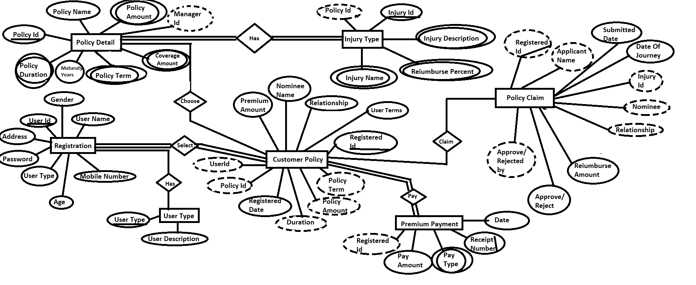

**Screens:**

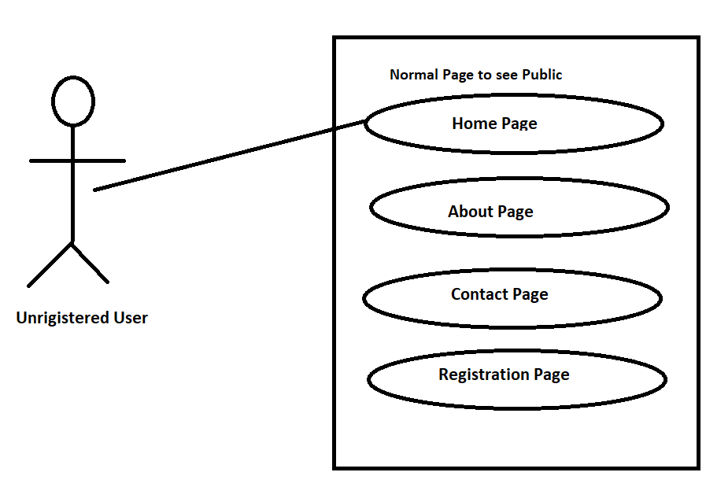

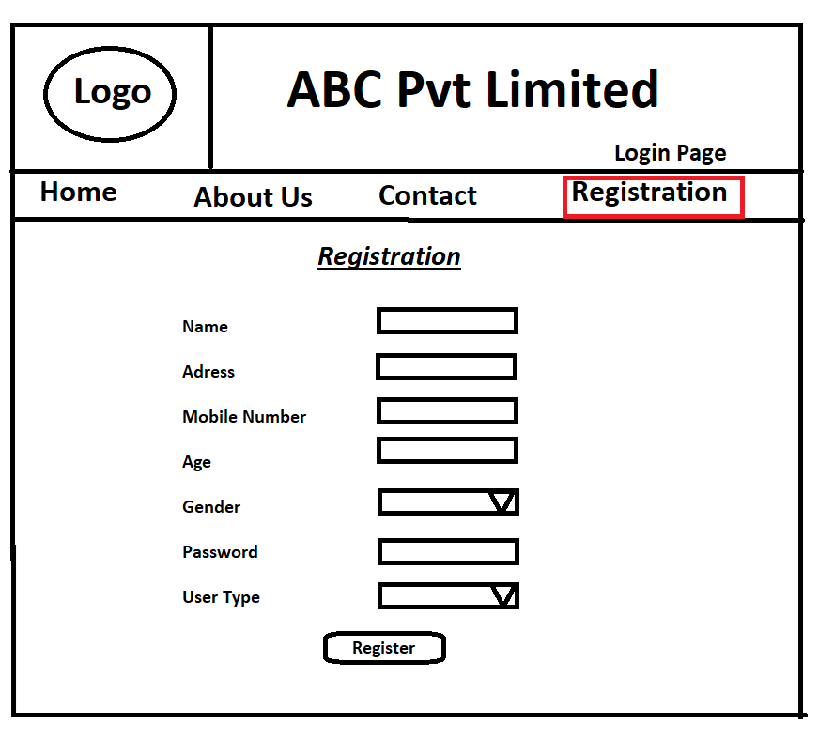

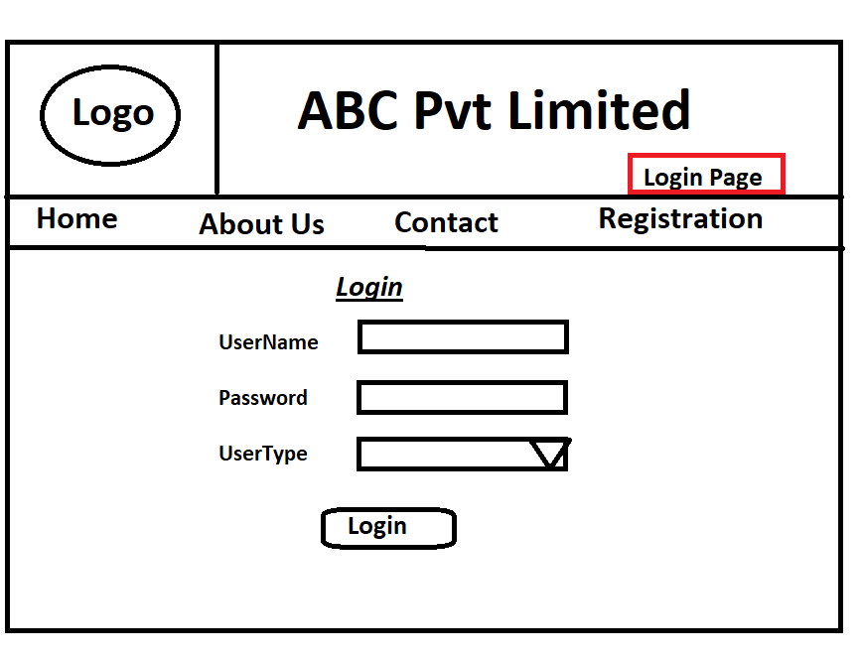

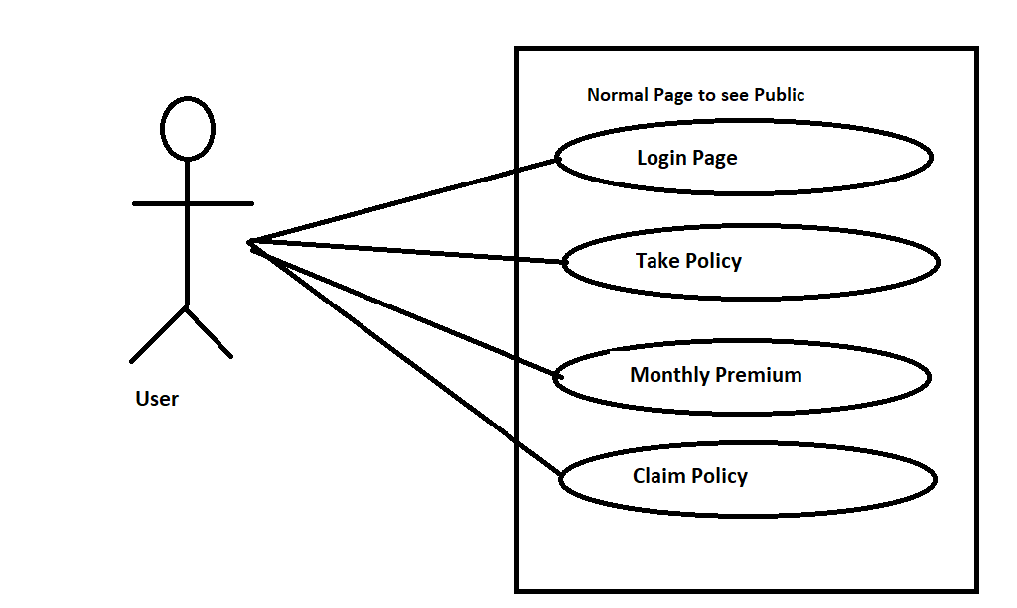

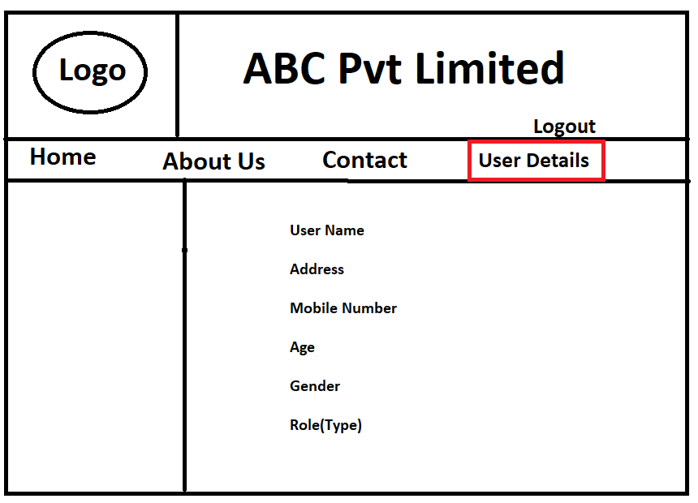

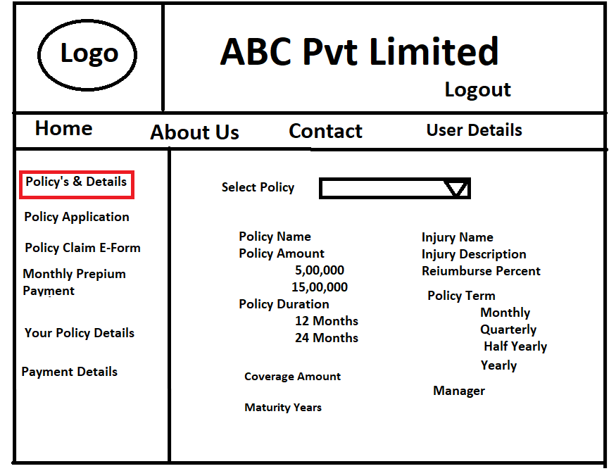

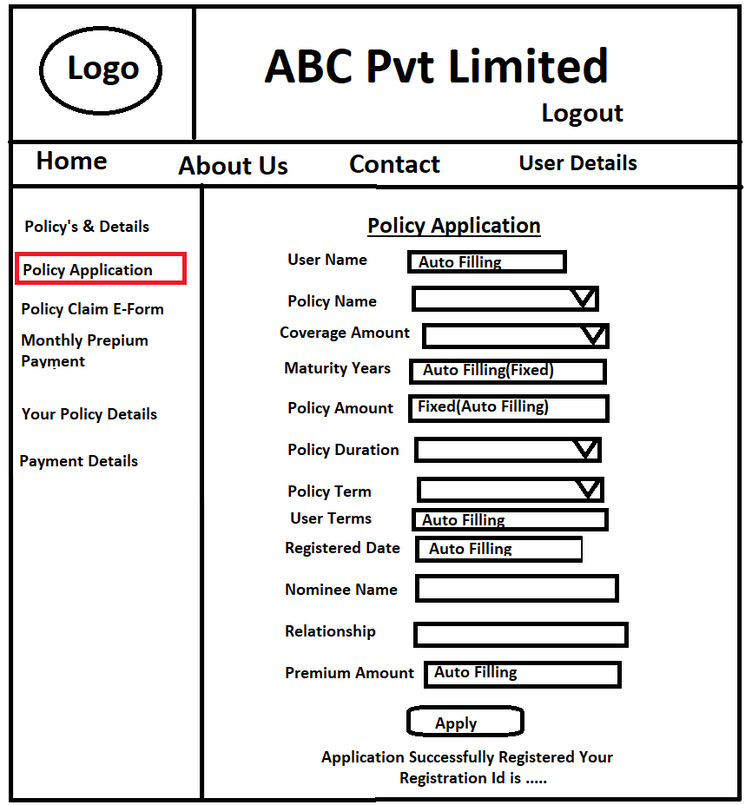

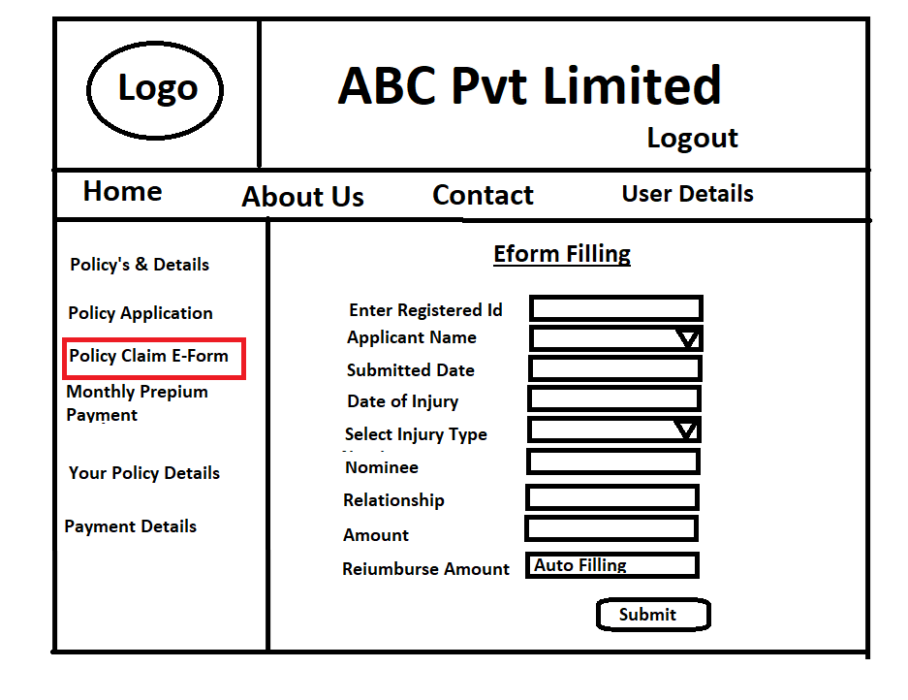

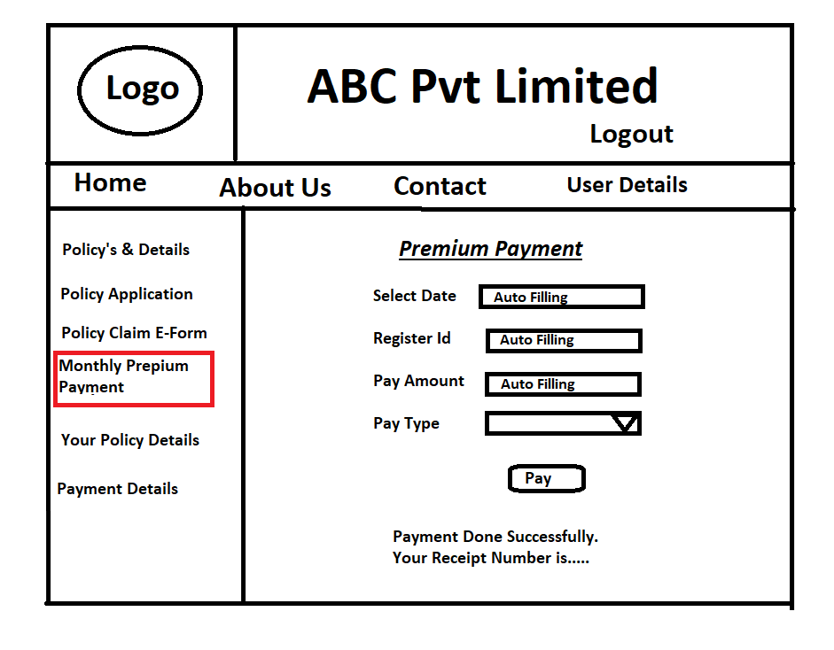

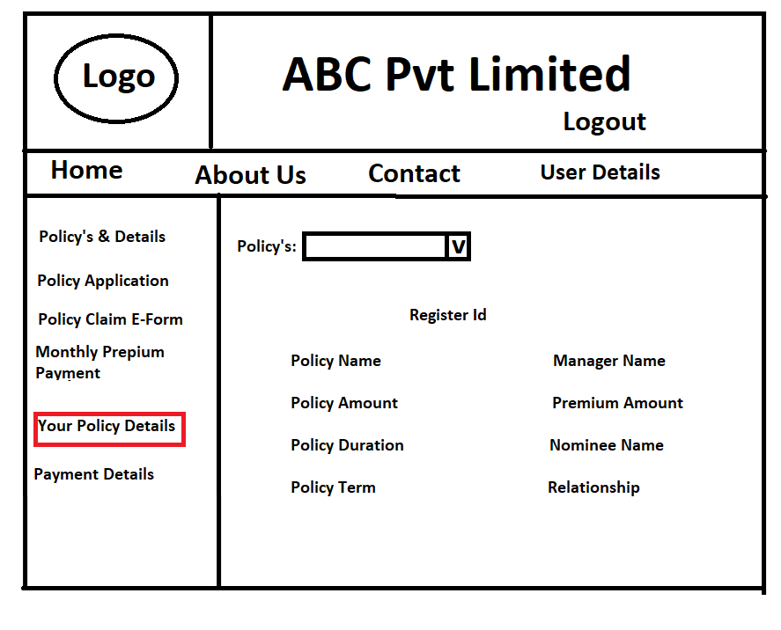

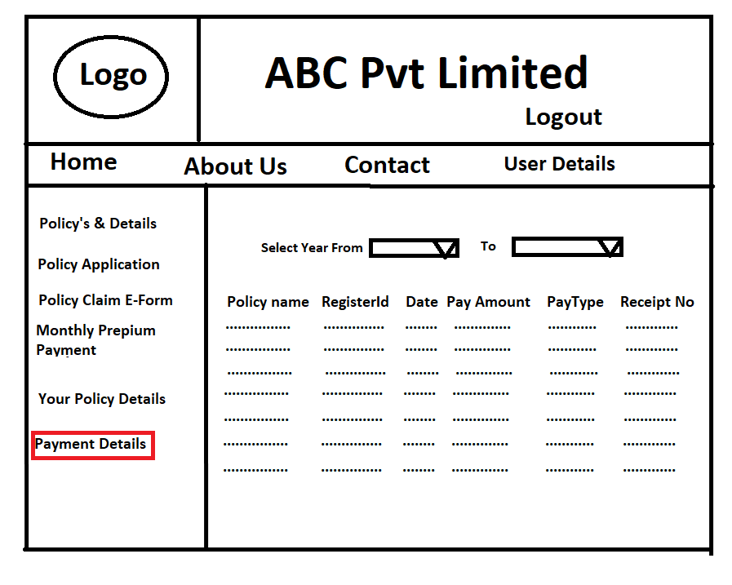

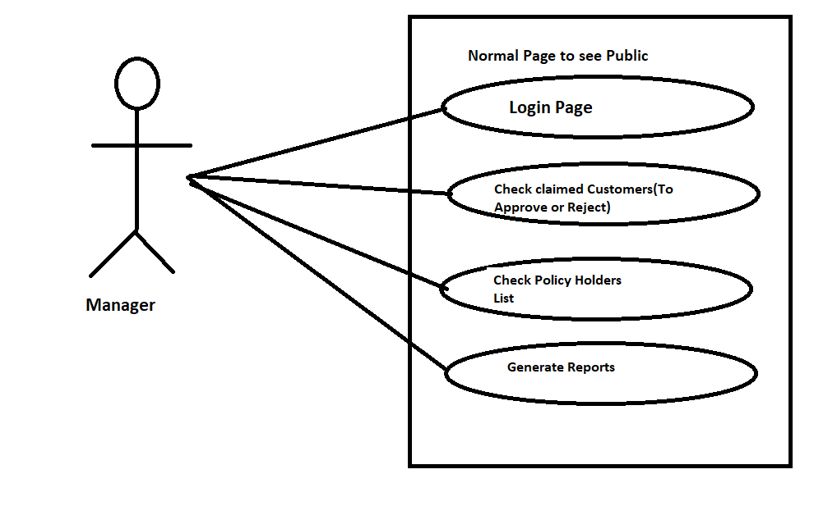

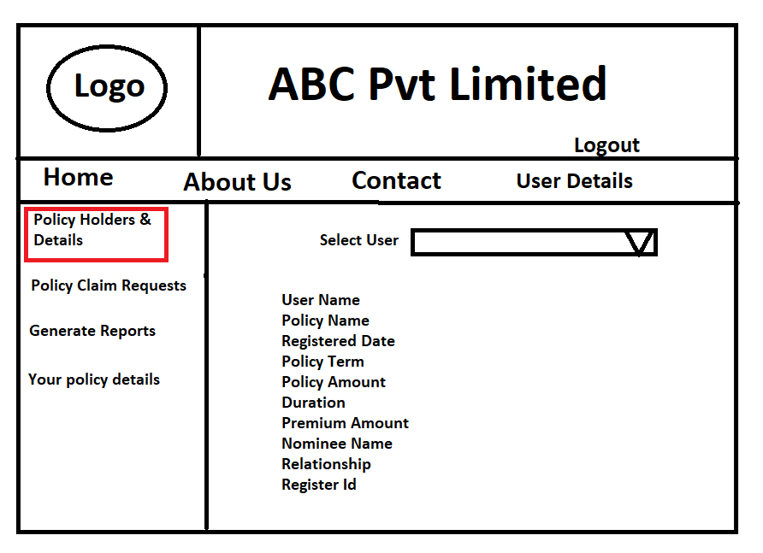

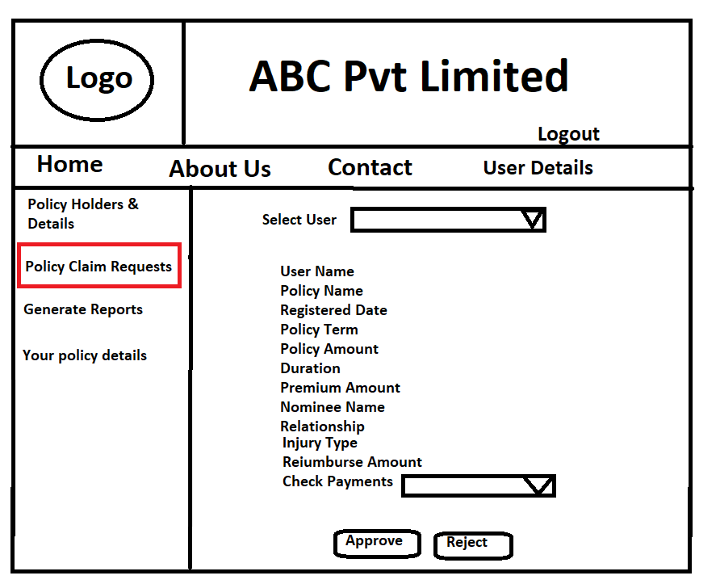

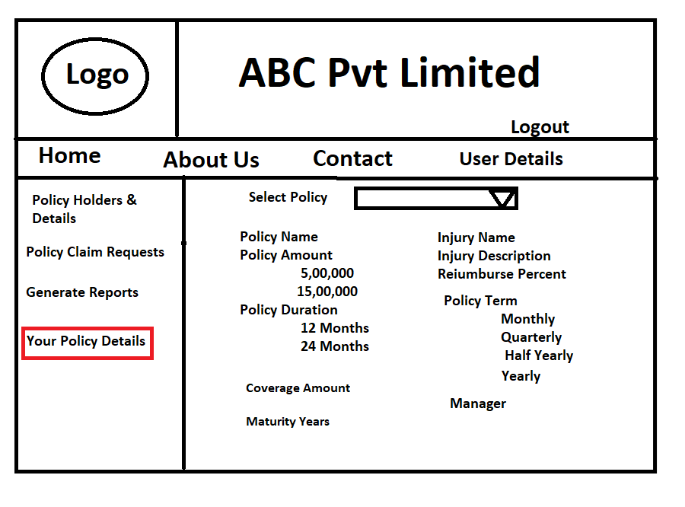

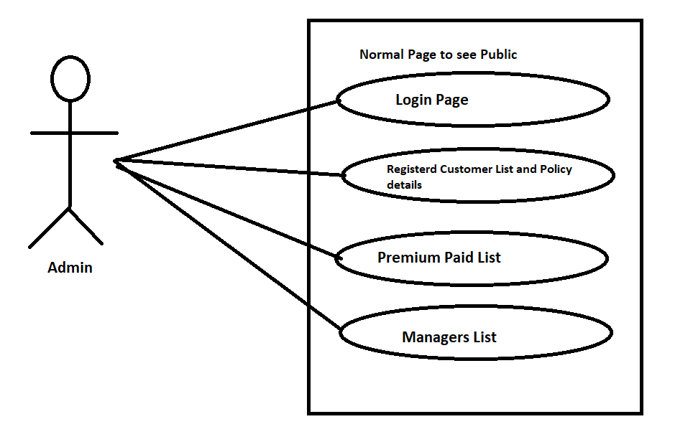

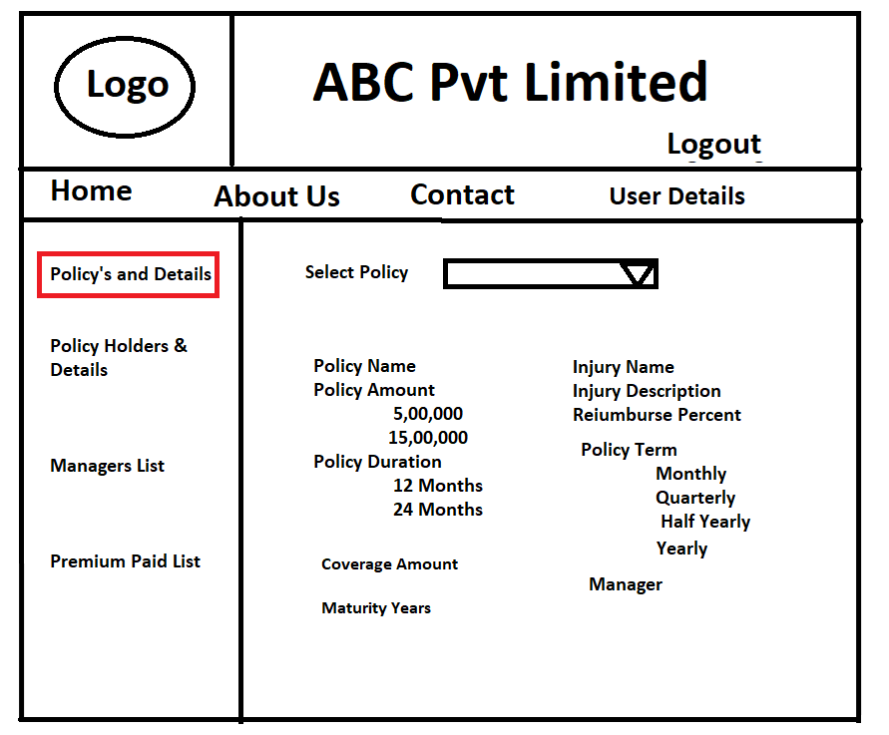

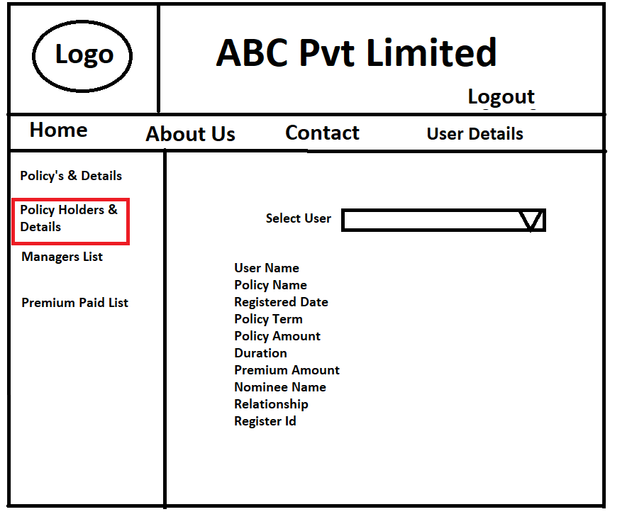

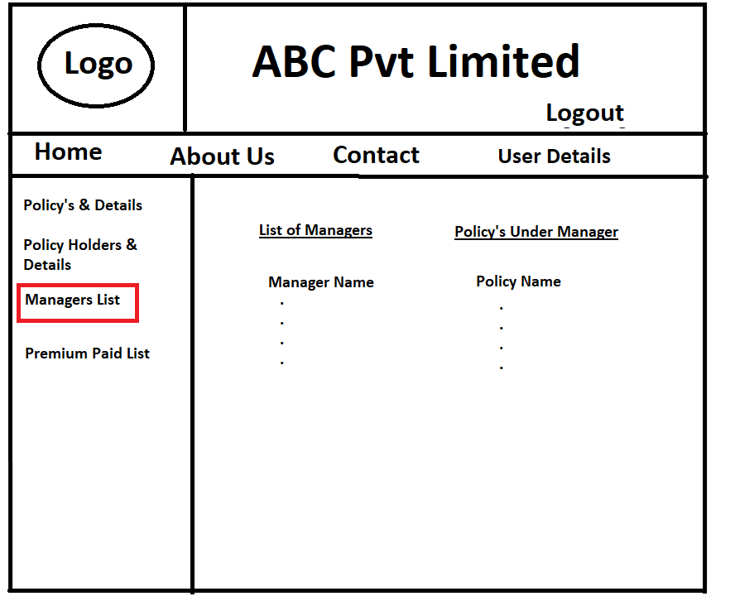

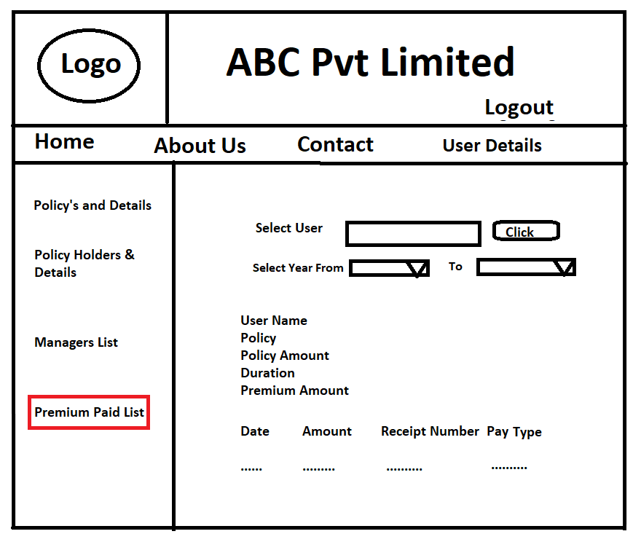

**DELIVERABLES:**

• The system should have a separate page for claim registration and login.

• The system should have very easy navigation from one screen to other.

• System should be able to provide Policy details and calculate reimburse amount for selected nature of injury.

• Manager should be able to Approve or Reject the claim requests of the policy claimant.